* + [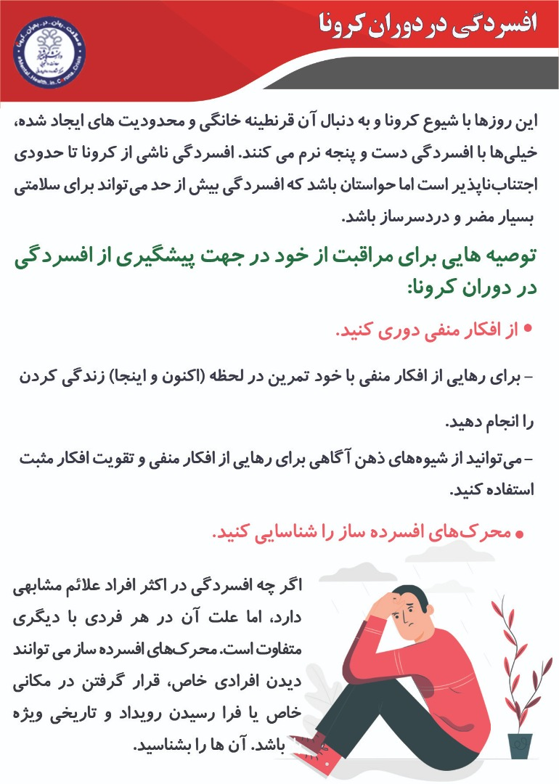](http://moshavereh.shirazu.ac.ir/web/wp-content/uploads/2020/05/%D8%A7%D9%81%D8%B3%D8%B1%D8%AF%DA%AF%DB%8C-%D8%AF%D8%B1-%DA%A9%D8%B1%D9%88%D9%86%D8%A71.jpeg)
  + [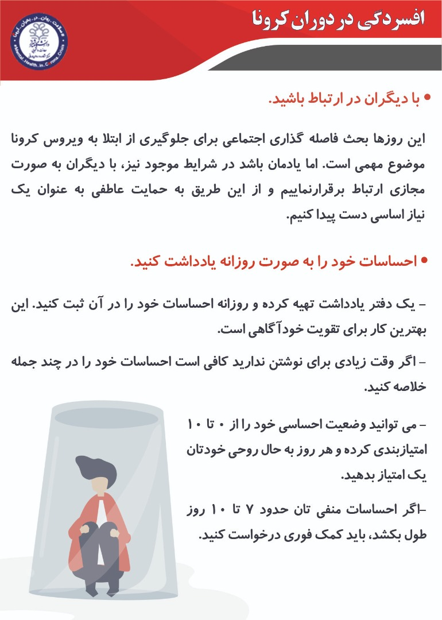](http://moshavereh.shirazu.ac.ir/web/wp-content/uploads/2020/05/%D8%A7%D9%81%D8%B3%D8%B1%D8%AF%DA%AF%DB%8C-%D8%AF%D8%B1-%DA%A9%D8%B1%D9%88%D9%86%D8%A72.jpeg)
  + [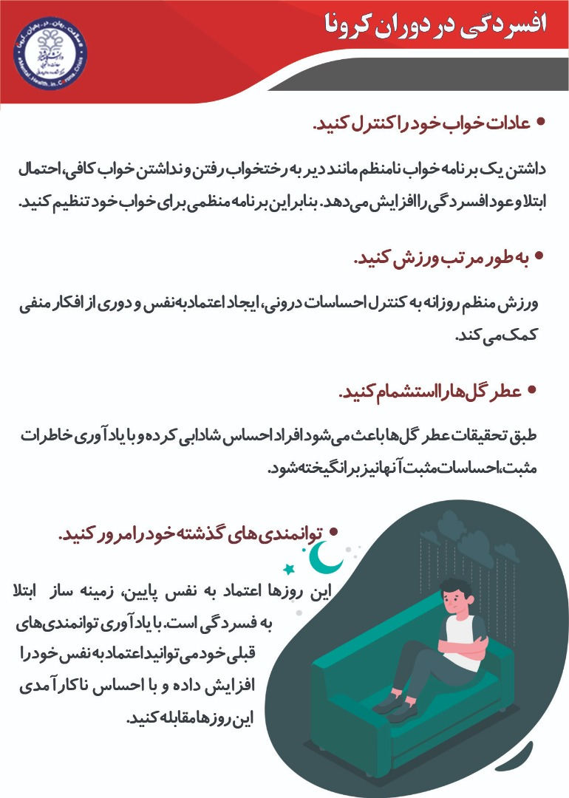](http://moshavereh.shirazu.ac.ir/web/wp-content/uploads/2020/05/%D8%A7%D9%81%D8%B3%D8%B1%D8%AF%DA%AF%DB%8C-%D8%AF%D8%B1-%DA%A9%D8%B1%D9%88%D9%86%D8%A74.jpeg)

[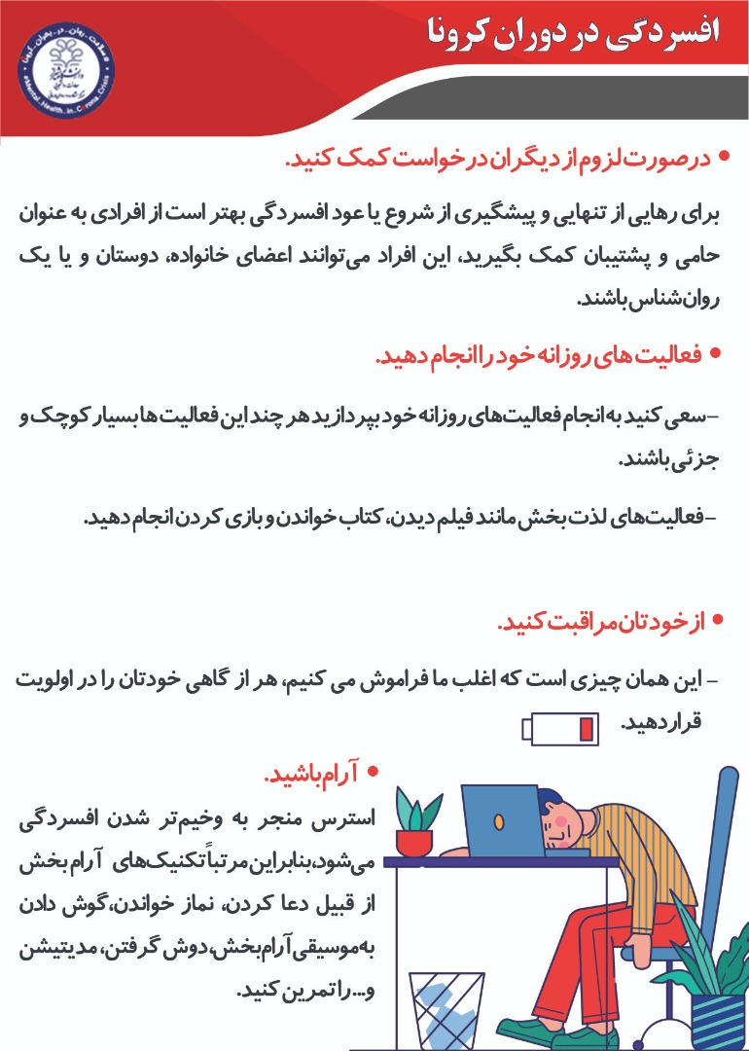](http://moshavereh.shirazu.ac.ir/web/wp-content/uploads/2020/05/%D8%A7%D9%81%D8%B3%D8%B1%D8%AF%DA%AF%DB%8C-%D8%AF%D8%B1-%DA%A9%D8%B1%D9%88%D9%86%D8%A73.jpeg)

[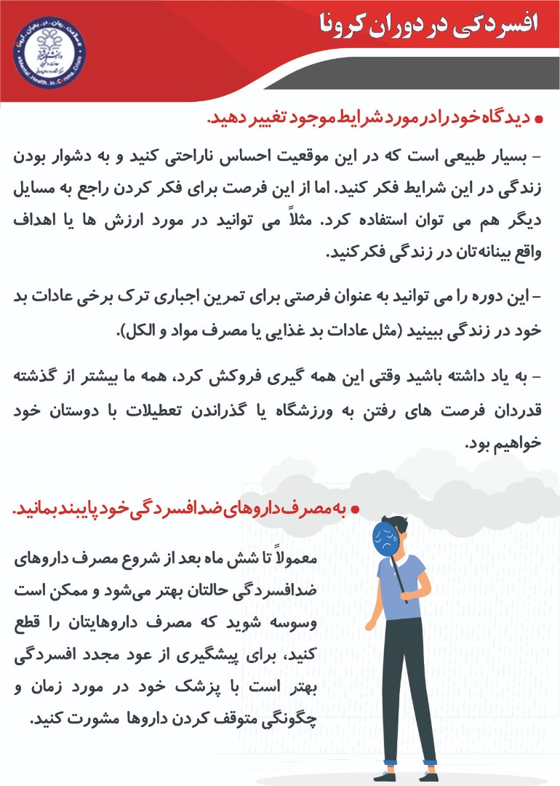](http://moshavereh.shirazu.ac.ir/web/wp-content/uploads/2020/05/%D8%A7%D9%81%D8%B3%D8%B1%D8%AF%DA%AF%DB%8C-%D8%AF%D8%B1-%DA%A9%D8%B1%D9%88%D9%86%D8%A75.jpeg)