Post graduate students in irancageculture 2018
No | photo | Name | Degree | Grade | Field | Cellphone | Email
 |  | Amir emdad Rastande | B.S. |  | Aquaculture | +989120232785 | emad.ras2020@gmail.com
 |  | Amir farshforoush Imani | Ph.D. |  |  | +989141049189 | A_farshforoush@yahoo.com
 | 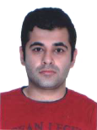 | Ardavan Farhadi | Ph.D. |  | Aquaculture | +989117900814 | farhadi219@yahoo.com
 |  | Azin Azari | Ph.D. |  | Aquaculture | +989121360468 | Azin.4azari@yahoo.com
 | 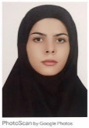 | Fatemeh Jafari | B.S. | 4th year | Plant protection | +989122332574 | fatemehjafari39 @ymail.com
 |  | Fatemeh Moshayedi | Ph.D. | 2nd year | Aquaculture | +989399344077 | Fateme.moshayedi@yahoo.com
 |  | Jana Arabzadeh | Ph.D. |  | Architect | +989121082477 | j.arabzadeh@yahoo.com
 |  | Javad Rahmani | M.S. |  |  | +989302133588 | javadrahmani1410@gmail.com
 |  | Kasra Lotfi | M.S. |  | Aquaculture | +989128078539 | Kasra.lotfi1995@yahoo.com
 |  | Maede Rashmai | Ph.D. |  | Aquaculture | +989127339305
 | 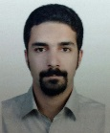 | Mahdad Mahdabi | Ph.D. | 2nd year | Aquaculture | +989125509406 | mahdad.mahdabi@gmail.com
 |  | Majid Afsharinia | M.S. | 2nd year | Aquaculture | +989124974789 | m.afsharinia@gmail.com
 |  | Mansure Kakavand | Ph.D. | 4th year | Aquaculture | +989127339305 | mansore.kakavand2222@gmail.com
 | 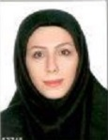 | Mehrnaz Mobini | M.S. | 2nd year | Aquaculture | +989126107264 | mobinimehrnaz67@gmail.com
 | 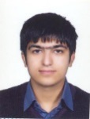 | Milad Mohammadi moghaddam | Ph.D. | 4th year | Aquaculture | +989126464851 | Milad.moghadam2014@gmail.com
 |  | Niloofar Razi | M.S. |  | Aquaculture | +989123165385
 | 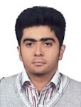 | Ramtin Hushangi | M.S. |  | Aquaculture | +989124356864 | m_tin_ra@yahoo.com
 |  | Ramtin Norouzi | M.S. |  |  | +989339984898 | Norouzi.ramtin@gmail.com
 | 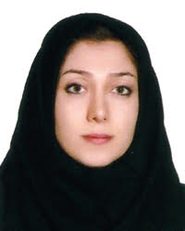 | Sahar Farahnak roudsari | Ph.D. |  | Aquaculture | +989127784403 | farahnaksahar22@yahoo.com
 |  | Zeinab Cheraghi | M.S. |  | Aquaculture | +989128105922 | zeinabcheraghi1372@gmail.com

