Country | Nationality | Language | Flag
Afghanistan | Afghan | Dari (Persian) | 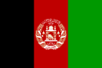
Argentina | Argentine / Argentinean | Spanish | 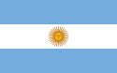
Australia | Australian | English | 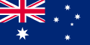
Austria | Austrian | German | 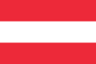
Belgium | Belgian | French / Flemish | 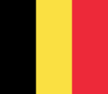
Bolivia | Bolivian | Spanish | 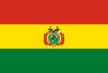
Brazil | Brazilian | Portuguese | 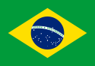
Cambodia | Cambodian | Cambodian | 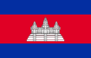
Canada | Canadian | English / French | 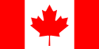
Chile | Chilean | Spanish | 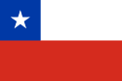
China | Chinese | Chinese | 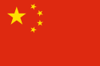
Colombia | Colombian | Spanish | 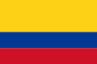
Costa Rica | Costa Rican | Spanish | 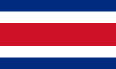
Cuba | Cuban | Spanish | 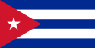
Denmark | Danish (Dane) | Danish | 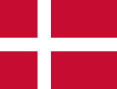
Dominican Republic | Dominican | Spanish | 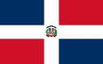
Ecuador | Ecuadorian | Spanish | 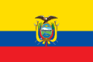
Egypt | Egyptian | Arabic | 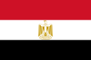
El Salvador | Salvadorian | Spanish | 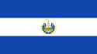
England | English | English | 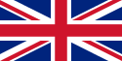
Estonia | Estonian | Estonian | 
Ethiopia | Ethiopian | Amharic | 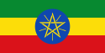
Finland | Finnish | Finnish | 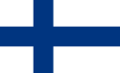
France | French | French | 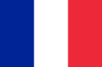
Germany | German | German | 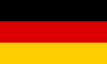
Greece | Greek | Greek | 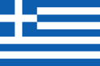
Guatemala | Guatemalan | Spanish | 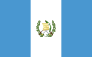
Haiti | Haitian | French / Creole | 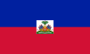
Honduras | Honduran | Spanish | 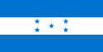
Hungary | Hungarian | Hungarian | 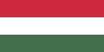
Indonesia | Indonesian | Indonesian | 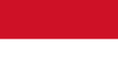
Iran | Iranian | Persian | 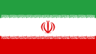
Ireland | Irish | Irish / English | 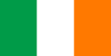
Italy | Italian | Italian | 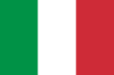
Japan | Japanese | Japanese | 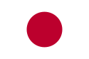
Jordan | Jordanian | Arabic | 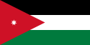
Korea | Korean | Korean | 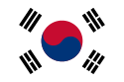
Laos | Laotian | Laotian | 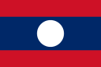
Latvia | Latvian | Latvian | 
Lithuania | Lithuanian | Lithuanian | 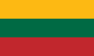
Malaysia | Malaysian | Malay | 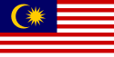
Mexico | Mexican | Spanish | 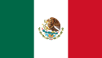
Morocco | Moroccan | Arabic / French | 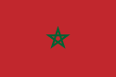
Netherlands | Dutch | Dutch | 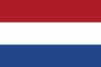
New Zealand | New Zealander | English / Maori | 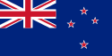
Nicaragua | Nicaraguan | Spanish | 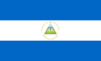
Norway | Norwegian | Norwegian | 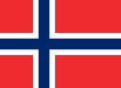
Panama | Panamanian | Spanish | 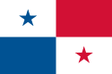
Paraguay | Paraguayan | Spanish | 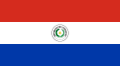
Peru | Peruvian | Spanish | 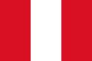
Philippines | Filipino | Tagalog | 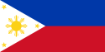
Poland | Polish | Polish | 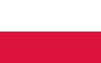
Portugal | Portuguese | Portuguese | 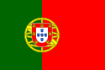
Puerto Rico | Puerto Rican | Spanish | 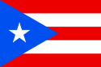
Romania | Romanian | Romanian | 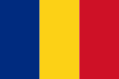
Russia | Russian | Russian | 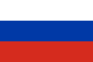
Saudi Arabia | Saudi | Arabic | 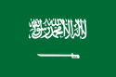
Spain | Spanish | Spanish | 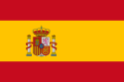
Sweden | Swedish | Swedish | 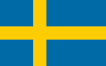
Switzerland | Swiss | Swiss | 
Taiwan | Taiwanese | Chinese | 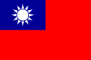
Thailand | Thai | Thai | 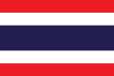
Turkey | Turkish | Turkish | 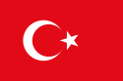
Ukraine | Ukrainian | Ukrainian | 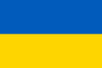
United States | American * | English | 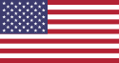
Uruguay | Uruguayan | Spanish | 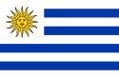
Venezuela | Venezuelan | Spanish | 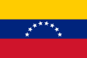
Vietnam | Vietnamese | Vietnamese | 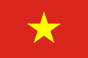
Wales | Welsh | Welsh / English | 