[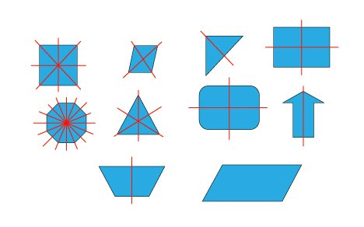](http://mohtavaonline.ir/upload/symmetry7-sh.swf)