“In the name of Allah “  آزمون میان نوبت دوم نام ...................  زبان انگلیسی " سال 1395 مبارک" نام خانوادگی ..........................  شعار امسال  آموزشگاه: مقام معظم رهبری: اقتصاد مقاومتی اقدام و عمل پایه: نهم  نام دبیر: ........................  تاریخ: 23 / 1/ 95  زمان: 60 دقیقه | ijiu

1.شماره مربوط به هر کلمه را زیر تصویر مربوطه بنویس. 3 نمره
1.text a massage 2.take out money from(ATM) 3. Fire work
4 .nuts 5.the national anthem 6. parad

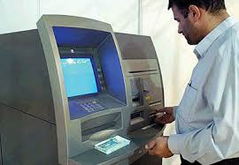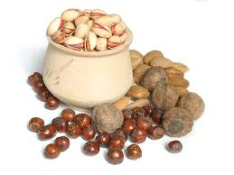

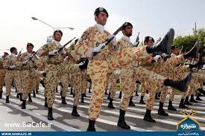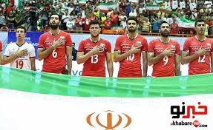

.........................................................................................................................................................
2. با نوشتن شماره مربوط به هر عبارت در ستون مناسب آنها را دسته بندی کنید. 4 نمره
Services Media Festivals Personality

1.Sing the national anthem. 4. Hold a ceremony. 7. Put out fire
2.Interview somebody. 5. Cruel boy. 8. Selfish boy.
3. Use IT. 6. Help charity.
…………………………………………………………………………………………………………………………………………………………………

3. بهترین گزینه را انتخاب کنید. 4 نمره
1. Which sentence has a rising intonation ?
a) I don’t set the table . c) Where do you go to school ?
b) Does she clear the table ? d) There are special foods on the table.

2) We can’t put out fire. Call the –mergen-y .
a) i/c b) e/c c) e/s d) i/s

3)Atoosa doesn’t like milk. She ………………. eats it .
a) usually b) always c) never d) often

4) Internet is a wonderful……………………… .
a) blog b) course c) media d) website

5) Which sentence doesn’t have a rising intonation ?
a) How fantastic ! b) It’s amazing !
c) Who is that man ? d) Do you celebrate your birthday ?

6)A: Where does she buy stamps ? B: She buys them from ……………….. .
a) the office b) the police station
c) the information desk d) the post office

7)A: It’s 8:20’. I’m hungry. ……………………………….? B: At 9:00’.
a) Where is the shop ? b) What time is it ?
c) Is it landing ? d) When’s the break ?

8) A: Why is your father buying new shirts and shoes ?
B: He wants to ………………………………….. .

a) open an account b) help charity
c) bring to the ER d) take out money
…………………………………………………………………………………………………………………………………………………………..
4.سوالهای زیر را با نوشتن کلمات پرسشی مناسب کامل کنید. 2 نمره
1. A:…………… does he work ? B: He works at a bank .
2. A:…………. helps charity ? B: Mr.Takbiri helps charity .
3. A:………… is your brother’s job ? B: My brother is a fire fighter .
4. A:………….does your mother get up ? B: My mother gets up at 8 .
5. A:………….do you go to school ? B: I hire a taxi to school .
6. A:………….do you do voluntary work ? B:I do voluntary work in summer .
7. A:………….do you hire a taxi ? B: Because I am late .
8. A:………… is the fire station ? B: It’s over there.
……………………………………………………………………………………………………………………………………………………………
5. جملات به هم ریخته زیر را مرتب کنید. 4 نمره
1. you/ did/ see/ movie/ a/ war/?
2. an e-mail /did’t/ you/ receive/.
3. when/ he/ blog/ his/ did/ upset/?
4. were /yesterday/ my relatives/ happy/.
…………………………………………………………………………………………………………………………………………..
6.پاسخهای مناسب را به سوالهای مربوطه وصل کنید. 3 نمره
a
1.Did he open an account ? Last winter
b
2. Who helped the lost girl ? The police man
c
3. When did they participate in the online course ? Yes, he did.
d
4. Why did he like his job ? I recharged my E-ticket.
5. How did you see the war movie ? Because he saved people’s
e
6. What did you do in the evening ? lives.
f
I download it from the
internet.
………………......................................................................................................................................................

سوال امتیازی : (2 نمره )

عزیزم در سه سطر کارهایی که برای عید نوروز انجام داده اید بنویسید.

………………………………………………………………………………………………………………………………………………………
………………………………………………………………………………………………………………………………………………………
……………………………………………………………………………………………………………………………………………………….

GOOD LUCK
Kamali




