Electronic Symbols.doc
Revision 20

Last modified July 6, 2011

You wouldn’t believe how many engineers download this free Word file each month!

This Word document contains some schematic symbols for use in Microsoft Word, PowerPoint and Excel files for reports and presentations. If you happen to have Agilent ADS or AutoCAD, you may find these tools more convenient for creating schematics. If you are a microwave cheapskate, you may have created these symbols yourself a hundred times. Using this downloadable file, now you won’t have to!

Did you find some useful schematic symbol(s) missing? Drop a line to techwriter@microwaves101.com and we’ll see if we can add it!

The Microsoft Word Drawings are pasted into tables to keep them “anchored” within the text. Just double-click on a figure to edit it. When you are editing a figure, remember that everything started out on a 0.05 inch grid. You may have to turn off the grid snap to get things to align properly.

Around the pictures (inside the Microsoft Word Drawings) are invisible boxes with clear filling. These are used to define the outside edges of the pictures.

Microsoft software does some peculiar things if you try to scale the pictures. We recommend that if your picture is too big, you should work on decreasing the size of the elements inside the picture rather than squeezing the entire picture down to size. Once you shrink any of the schematic elements, all bets are off as to whether they will look aligned when you connect them up.

It is very simple to copy from one picture to another. You need to double-click the picture you are copying from, then click and control C the element you want to copy, then exit the picture, click into the second picture and hit control V.

Good luck!
Resistors, capacitors and inductors
Coax, ferrite bead
FETS and transistors
Attenuators, circulators and isolators
Double-balanced mixers
Diodes, DC blocks, mixer, phase shifter/attenuator
Filters and multiplexers

Lumped Filters
Switches
Branchline hybrid couplers
Rat race coupler
Wilkinson power splitters
N-section Wilkinson, Even/odd modes
Phase shifters
Switch configurations
Three-way Wilkinsons
Resistive splitters
L-Pad
Owen resistive splitter

Gysel power splitter

Detector circuits

Meters, power supplies and batteries

Resonant circuits

MOSFETs and Drivers
Logic
Receivers

Capacitor model

Voltage and current sources, transmission line model

MEMS switches
Lange couplers. balanced amp

Doherty amp

TR modules

The FET images below came from James. Thanks!!

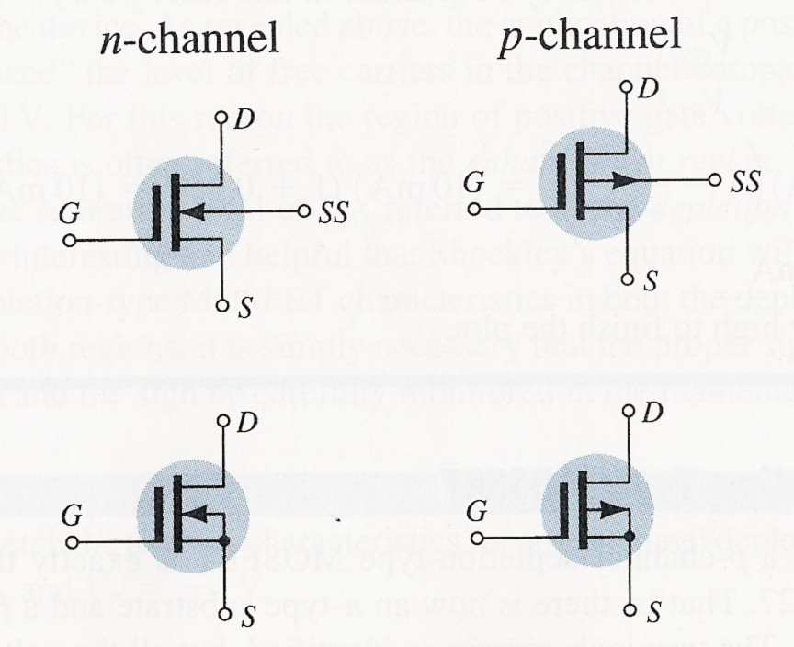

Depletion mode MOSFET

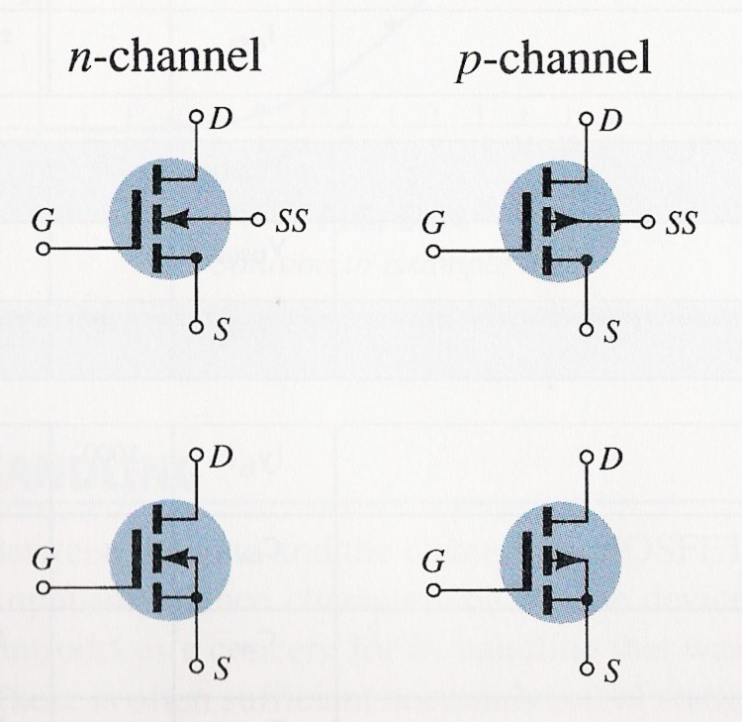

Enhancement Mode MOSFET

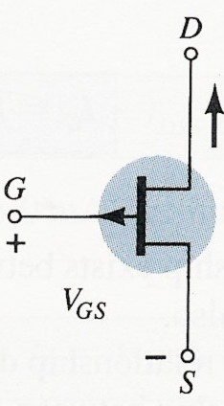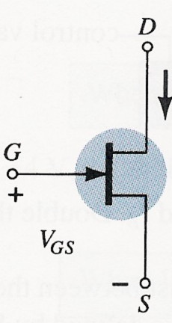
p Channel JFET n-channel JFET

