" In his Name "
Full name : grade : 7 section : Subject: English- Lesson(5&6)
Fasa farzanegan junior highschool
"Part 1"
Write a correct word based on the pictures and the unscramble letters. (3.5)


1- ( p – a – c ) ………………………………..
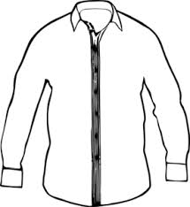

2- ( h –i– t – r – s ) ………………………………..

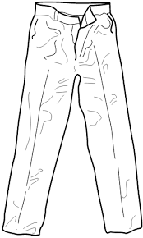
3- (t– a – p – n - s ) ……………………………………


4- ( w – s - e – a – t – r – e ) …………………………..

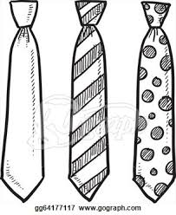
5- ( s – t –i- e ) …………………………………

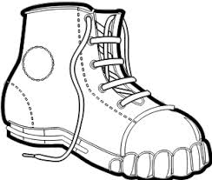

6- ( o – s – h –e ) …………………………
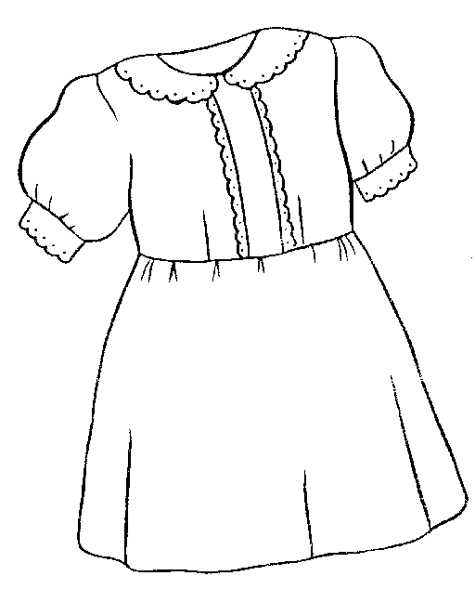

7- ( d – s – e – r – s ) ……………………………
رنگ بنفش
8 – ( p – u – r – l – e - p ) ………………………………

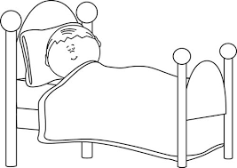
9- (d – r – o – m – b – o – e) ……………………………….
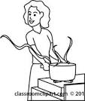

10 –( t –i– k – c – h – e – n ) ……………………………

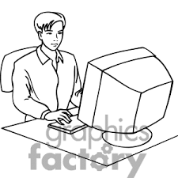
11 – ( f – f – e – c – i - o ) ………………………

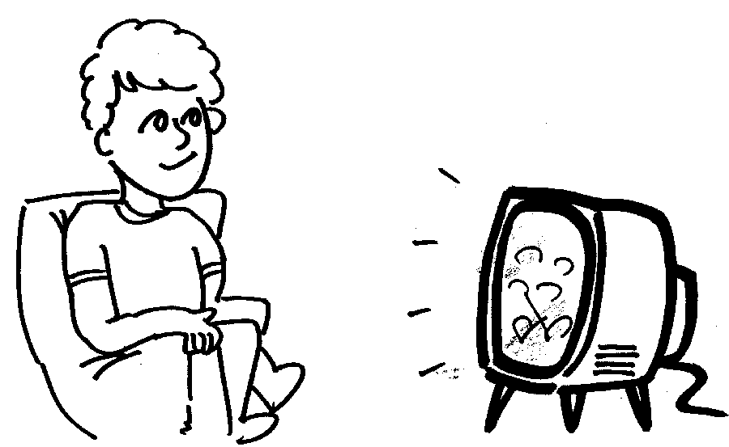
12- ( w – t – a – h –c ) ……………………………….


13- ( h – u – o - s – e ) ………………………………

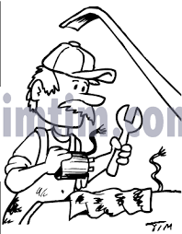
14 –( f – x – g –i– n –i) ………………………………

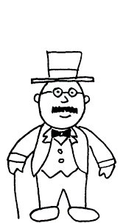
" Part 2 "
Read the text and color the picture .( 1 )

Mr. Shams is a boss. He usually wears a black suit with gray vest.
His glasses are brown. He likes a dark blue hat.

"Part 3"
girl trousers math wearing tall gray
Complete the text with given words .( 3)
A

Mrs. Taslimi , my ……………………. teacher , is a …………………….. woman.

She is ………… a …… manteau. The short …………………. is my friend, Zahra.

She's wearing pink ………………. and a yellow scarf.
B
Studying – cooking – living room – reading - computer games - brother

Today is Friday. We are ar home . My father is ………………… a newspaper in the ………………….. .

My mother is ………………….. . My …………….. , Milad , is playing ………………… in his room .

My sister is ………………….. her English book .

" Part 4"
Choose the best item. (2)

1- Ali is a tall boy . He's not …………………. .( long – short – fat )

2- My grandfather is 80 years old. He is …………………………. . ( young – old –tall )

3- . The sky is ………………. . ( black - yellow – blue ).

4- Which …………….. is Laleh ? She's the tall girl . (old – one – ones )

5-A room where there is a bath for washing is ……………. . ( WC - bathroom – bath tube )

6- There are a lot of flowers in the ………………… . ( garage - garden – storeroom )

7- A …………………. is a cover for a bed. ( carpet – pillow – blanket )

8- You're untidy ! Do you have a …………….. ? ( tower- towel – mirror )

"Part 5"
Order this conversation between Farid and Farnia . (1.5)

She's in the livingroom. Farid : ……………………………………………………

What is she doing ? Farnia : ……………………………………………………

Is she wearing her glasses ? Farid : …………………………………………………………

She's reading a newspaper . Farnia : …………………………………………………

No, she isn't . Farid : ……………………………………………………..

Where is Mom ? Farnia : …………………………………………………….

"part 6"

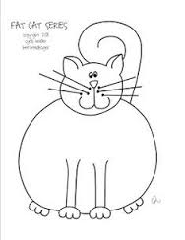
Answer the questions with proper words based on the pictures. (3)

1- Is the cat thin ? No, it's ………………………….. .
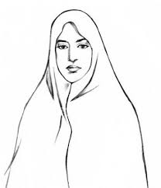

2- Who is Miss Javadi ? She's wearing a black ……………………….. .
Pat
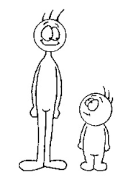

Mat
3-Which one is Pat? He's the ………………… boy .

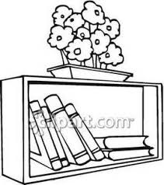

4 – I have a small ……………………….. .

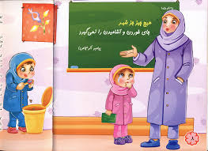
5- A ………………… teaches at school .

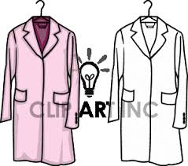
6- Iranian girl wear ……………………………. at school.

"part 7 "
Describe your mother in two lines.( about 4 sentences ). (2)

......................................................................................................................................................................

.....................................................................................................................................................................

" part 8"
Read the text and answer the questions .
Maryam is my best friend . She's a young nurse . She works in a state hospital . Her favorite color is brown . But when Maryam is at work, she's wearing a white uniform with dark blue scarf. Her shoes are white , too .

Answer the questions based on the text . (2 )

1. What's her favorite color ? It's ……………………… .

2. Is her scarf blue , too ? ……………………………………………. .

3. Where does Maryam work ? She works in a …………………………. .

Put true ( T ) or false ( F ) ? (1)

1. Maryam is teenager . ( )

2. Maryam doesn't like brown . ( )

"part 9 "
Match the questions with the answers. ( 1 )
A B

1- Who 's your friend, Maryam ? ( ) a. yes, He's teenager.

2- When is your birhday ? ( ) b. She's the tall girl.

3- Is his uncle 13 years old ? ( ) c. He's a mechanic.

4- What does Mr. Amini do ? ( ) d. It's in July 18th.

