**In the name of God**   
 **First name:………………………………. Last name:…………………………………………. Teacher : Sadeghi**

**School name:…………………………….. Prospect2- Khordad**  Time : 70 min

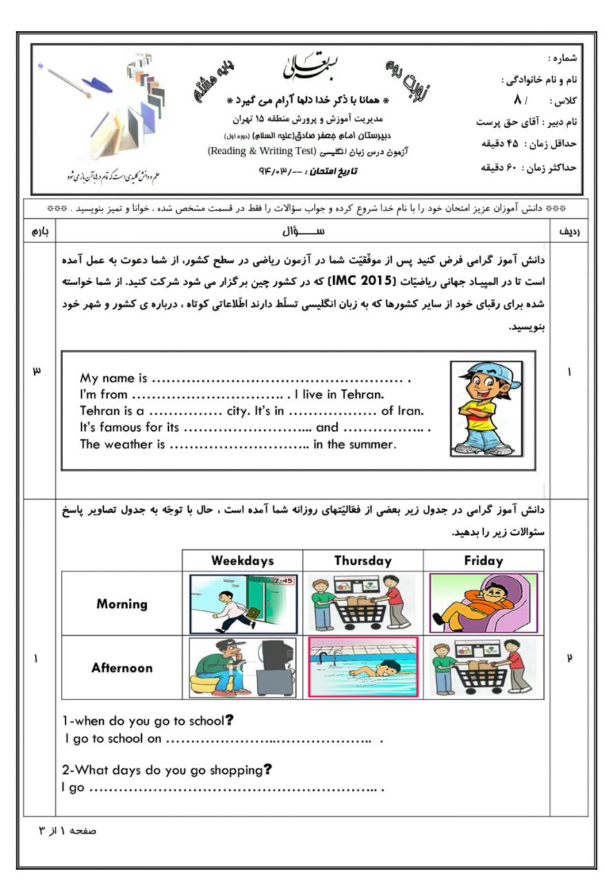 Date : 1398/3/11

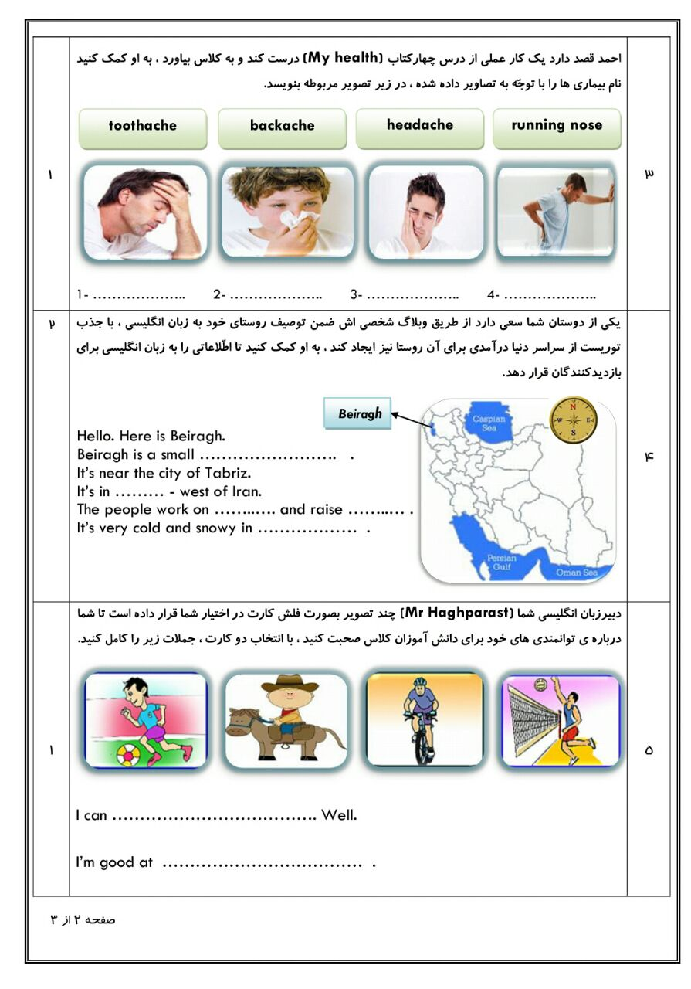

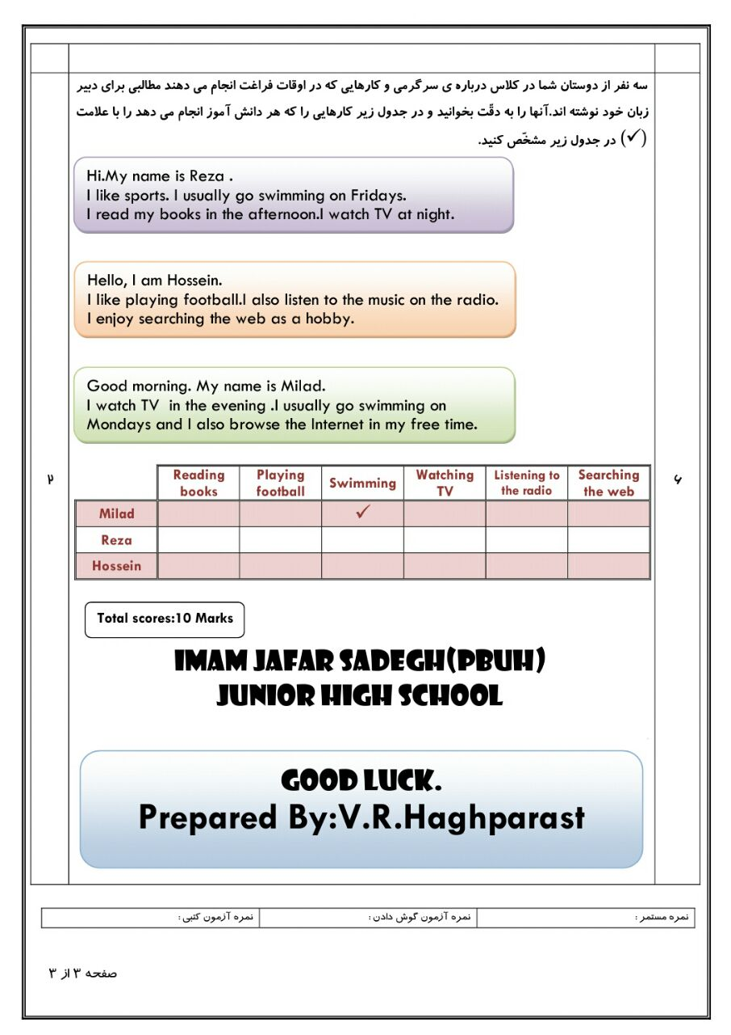

F:\Image\2two\LND209.WMF