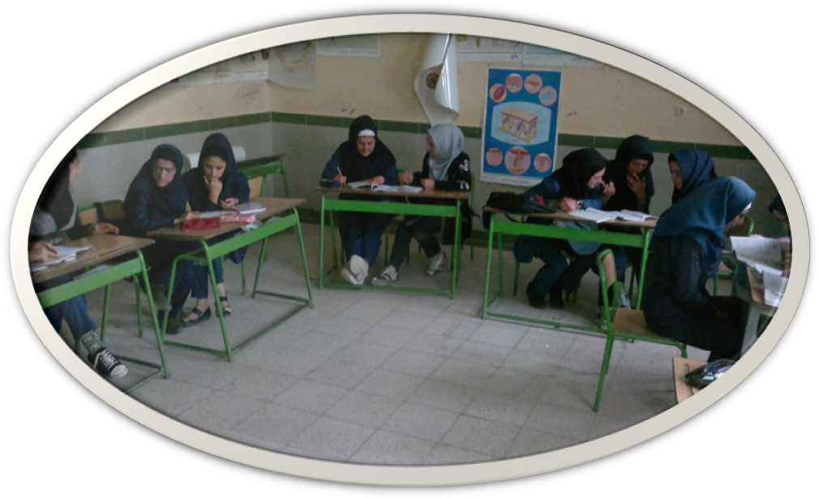
Instructor:
MasoumehSamadiOsalu
From:
SumayBradust Strict, Urmia, West Azerbaijan
Date: July, 2015

Subject: English book 3 Book code: 252 / 1
Grade: 3 Level: High school
Field: All fields School name:
Lesson Topic: Vocabulary drills Class name:
Of lessons 3 & 4(Ps 52 & 65) Number of students: 9
Number of lesson plan: Time: 30 minutes

In God we believe

Timetable fit: This is the first session of the second semester. The previous session was spent on teaching grammar and language function. Students were asked to review lesson 3 and be prepared for the new lesson. This session, the final part of lessons 3 & 4 (vocabulary drill) will be taught.

General Objective |  | Introducing students to word formation processes
Specific objectives: |  | At the end of this class, students will:  1. be introduced to common types of word formation processes  2.recognize different word forms in different sentences  3. understandthe application of different forms of words in authentic situations such as a description of a scene
BEHAVIORAL OBJECTIVES | Cognitive domain | At the end of the class students will: | knowledge | comprehension | Application | Analysis | Synthesis | Evaluation
BEHAVIORAL OBJECTIVES | Cognitive domain | -learn noun forms of guide, invite, migrate, exist, and explain, hot, wide, long, deep, and high. | *
BEHAVIORAL OBJECTIVES | Cognitive domain | -differentiate nouns from verbs and adjectives |  |  |  | *
BEHAVIORAL OBJECTIVES | Cognitive domain | -make nouns out of verbs |  |  | * | *
BEHAVIORAL OBJECTIVES | Cognitive domain | -be able to choose suitable forms of words in different sentences |  |  | * |  |  | *
BEHAVIORAL OBJECTIVES | Cognitive domain | -make sentences using different forms of words |  |  | * |  | *
BEHAVIORAL OBJECTIVES | Affective domain | Students will:  -get together and make groups in a random mode  -collaborate in a group work to win the game  -receive teacher’s corrective and affective feedback(rapport)  -given positive cards for doing well  - correct each other’s answer (peer correction)
BEHAVIORAL OBJECTIVES | Psychomotor domain | Students will:  -stand up and go around the class to find their fellow group members  -set their groups and put their desks in U form  -get together in their groups and stick the papers on the panel  -stand up and go to the desk with the circuit on it and get together to make the lights of the circuit on  - get together to do group works  -come to the board to answer the questions  -stand up and gather around the desks to do hand on knees game  -grab the cards on the desk with noun forms on them
Materials |  | Textbook, list of names, slides,3 packets of papers for 3 activities (Appendix. A, B,& C), music, a circuit with 6 lights on it, a piece of related listening, a piece of related film, Laptop, Speaker(for listening), Internet, a web based computer exam, paper and pencil, wireless mouse
Teaching Methods, techniques, & strategies |  | Task based language teaching, CLT, brain storming, Listening and watching authentic materials: role playing (made by students for listening and movie part in advance), ask and answer, PPP (presentation, practice, and performance), collaborative learning and teaching, problem solving, elicitation, reiteration, exposure to language
Class organization |  | -At the beginning students sit as they like; after the warm up stage, they will randomly be divided into groups and will set their chairs (or desks) in U form while the desk of each group is separated from another group.  - Before starting the class, the teacher asks the students to put a table in one corner of the class and put the circuit on it (the circuit is first inside a plastic bag in order not to distract students)  -In case there are chairs instead of desks in the class, the teacher prepares desks before starting the class for the “hands on knees” game.

Time(min) | Stage | Step by step objectives |  |  |  | Teacher Task | Students’ Task | Interaction | Materials | Appendix
1 | Greeting | -To establish a friendly atmosphere |  |  |  | -The teacher enters the class and greets Ss.  -The teacher calls the roll and makes eye contact with them while paying attention and showing respect to them.  -The teacher checks if a student was absent the previous session and seeks the reason | -Ss also greet the teacher.  -Ss raise their hands or say “present” or “I’m here” to show that they are present  -Ss answer the teacher if needed | T-S &  S-T | List of names | ---
2  1 | Warm up | -To set the ground to start the session  -To set the scene and take students’ attention to forms of words and derivation and relate the lesson to real life |  |  |  | -The teacher starts the class in the name of Allah and emphases to begin every work with the name of God by presenting a saying and asks the students if they know why we start everything with the name of Allah.  - The teacher briefly refers to two words(hopeless end & endless hope) to arouse students’ attention to the difference which is the topic of the lesson(word formation) | -Ss pay attention to the teacher and the saying on the board and reply to the teacher’s question  -Ss think about the difference between the two words and listen to the teacher | T-S&  S-T  T-S | Slide:  2-3 | ---
2  1 | Warm up | -To give a preview of the activities |  |  |  | -Giving the outline of the session activities | -Ss listen to the teacher | T-S | Slide: 4 | ---
1  1  1  1  1  1  1  1  2  1  2  1  30 secons  30s  30s  3  3  1  1 | Diagnostic evaluation
 | Diagnostic evaluation | Review checking homework  Grammar |  | -To check students’ homework  -To check what Ss have learned from previous lesson  (grammar) |  | -The teacher asks her assistant if she had checked students’ homework before the teacher entered the class (every session, before teacher’s coming, the assistant is responsible to check the homework). The teacher checks if there was any problem with the homework  -The teacher asks the topic of grammar (two word verbs) and stimulates student’s answers( ask & answer method) | -The assistant reports how the students have done their homework and if there was any problem  -Ss answer teacher’s questions | T-S & S-T  T-S & S-T  T-S | Slide 5  Slide: 6 | ---
 | Diagnostic evaluation |  |  | -To randomly divide Ss into groups while doing a task based activity to review two-word verbs  -To review what Ss have learned from grammar |  | -The teacher gives each of the Ss a piece of paper. On some of themdifferent types of separable tow-word verbs, on some others inseparable tow-word verbs, and on the rest one-word verbs are written.  - The teacher shows her satisfaction of the students’ effort(rapport)  - The teacher ask some questions while showing some picture to review grammar part taught in the previous session.  -The teacher gives each group of students a packet of papers with scrambled words on them. They are asked to unscramble them and stick them on the panel. During the group work music is played. The teacher emphasizes that the group which finishes the task sooner is the winner. She gives positive cards to winners  f. The teacher shows her satisfaction of the students’ effort | -Ss are supposed to find their fellow group members, get together, and sit in a group.  -Ss look at the slides and answer teacher’s questions.  -Ss stand up and start to stick the papers on the panel to make a sentence out of scrambled words  -Ss get their positive cards | S-S  T-S & S-T  S-S  T-S | Slides: 7-8  Slides:9-12  3 packets of papers for 3 groups with words on them  Slide 13& music | Ap. B Ap. A
 | Diagnostic evaluation | Language function |  | -To relate what they have learnt in language function to the real world realities |  | -The teachers asks some questions about students’ free time and this paves the way for setting the scene for the next stage (teaching word formation) | -Ssanswers the teacher’s question by referring to some of their hobbies | T-S & S-T | Slide: 14 | ---
 | Teaching g part 1  Arousing motivation | -To prepare students for the next stage |  |  |  | -The teacher reads a verse from the holy Quran related to the variety of languages and elicits the required answers and relates them to the main subject which is word formation  - The teacher presents some quotations on the importance of words | -Ss think and answer  -Ss see how important words are | T-S & S-T  T-S | Slide: 15-17 | ---
 | Teaching vocabulary drill of lesson 3 | -To introduce students with different word formation processes  -To teach some suffixes including: tion, ance, and ence  -To involve Ss in a problem solving and at the same time a communicative task to discover the correct form of nouns made by derivation.  -To introduce students to the pronunciation of the new words |  |  |  | -The teacher introduces different word formation processes. Among those word formation processes, the teacher emphasizes “derivation” and provides some examples.  -The teacher refers back to the third slide and reminds the students of the two phrases they have seen in the start of the class (hopeless end & endless hope)(reiteration)  - The teacher challenges students with asking them to guess the correct suffix for each verb  -The teacher shows a circuit which is designed for teaching suffixes and asks the Ss to try and put the suffixes in their correct slots, the lights of which will be on, then. During this phase the teacher monitors the students and offers her help whenever needed. After eliciting the correct answers, the teacher introducesstudents to the pronunciation of the new words | -Ss listen and pay attention to the slides  -Ss remember the slide and find out the relation  -Ss try to guess the correct answers  -Ss stand up, go to the desk on which is the circuit and try to make it’s lights on by guessing the correct suffixes of the verbs and telling them to the teacher(problem solving & collaborative learning)  -Ss repeat the words after the teacher | T-S  T-S & S-T  S-S & S-T  T-S &  S-T | Slide: 18  Slide: 19  Slides: 20  A circuit with 6 lights on it  Slide: 21  : 21  Slide: 23 | ---
 | Teaching vocabulary drill of lesson 3 | -To enable students to manipulate the correct form of the words (verbs or noun form) in different sentences and distinguish verbs from nouns, as well as identify the patterns used with different parts of speech |  |  |  | -The teacher asks the students to listen to a conversationand fill in the blankson the sentences shown in the slide ( she mentions that these sentences are extracted from their books so they can either see them in the slides or in their books on page 52)  -The teacher elicits the words used in the conversation  -The teacher asks the students to get together and use brain storming strategy to find the patterns related to the use of nouns and verbs in the sentences while using their known knowledge (relating the lesson to whole book) | -Students listen to a conversation(exposure to Lg) between two people( the taught words are used in the conversation) and write down the required words(learning by doing a task)  -Students get together to discover the patterns used in the sentences and raise their hands to tell them | S-S & S-T Individual students  T-S  S-S & S-T  S-S | Slide: 22-24&  Listening sound provided by some students in advance& textbook
1 | Link to next stage | -To prepare students for the next part of teaching |  |  |  | -The teacher explains other forms of word formation related to next part of teaching | -Ss look at the slide and listen to the teacher | T-S | Slide: 25
1  1  2 | Teaching vocabulary drill part of lesson 4 | -To introduce students with another word formation process  -To teach some adjectives which have similar noun forms and to enable students to distinguish adjectives from their similar noun forms  - To enable the students to manipulate the correct form of the words (adjective or noun form) in different sentences |  |  |  | -The teacher presents some sentences and explains how we can produce other forms of words and create different sentences by making nouns out of adjectives  -The teacher presents (presentation) some adjectives and asks students (she calls the name of low level students to raise their self-confidence since this task is an easy one: paying attention to individual differences) to find their noun forms from the provided words based on their similarities  -The teacher asks the students to open their books on page 64 and find the sentences chosen from that part;they are asked to fill in the blanks first by guessing and then check their answers while watching the movie(practice) | -Ss listen and pay attention to the teacher  -Ss look at the adjectives and find their noun form based on the similarities and tell them to the teacher  -Ss open their books and find the chosen sentences; they try to guess the correct words  -Ss watch a piece of film which is about two students who watch a photo album and have a conversation about the scenes (the taught adj and noun forms are used in the conversation) and check their answers  -Ss come to the board and telling the answers explain why they have used noun or adj forms | T-S  T-S & S-T  Individual students | Slide: 25  Slide: 26  Slide: 27-29  &  book  A piece of film | ---
1  1  2 | E  V  A  L  U  A  T  I  O  N  C  O  N  C  L  U  S  I  O  N |  | Summative assessment |  | - To evaluate what Ss have learned individually  -The teacher evaluates the students’ learning of the whole session | -The teacher sets hands on knees game  -The teacher asks the students to make a sentence(performance) using the words they have learned in that lesson; then she asks some of them or all of them (in case of enough time) toread their sentences to the class  -The teacher connects to the net and sets the computer based quiz she has shared in his website and asks the students to answer some of the questions(IT based task)  -The teacher shows her satisfaction of the students’ effort | - Ss stand up and get together on 3 groups to play a game (hands on knees) to show their ability in distinguishing noun forms of the words the teacher reads; Ss grab the noun form of the words the teacher reads  -Ss make sentences of their own using the words they have learned and tell them to the class  -Ss collaborate to answer the questions of the quiz | T-S  &  Individual students  T-S & S-T  T-S | Slide: 30  Paper and pencil  Slide:31  Internet connection | Ap. C
1 |  |  | homework assignment |  | -To practice what Ss have learned at home  -To assign ICT based homewok  -To pay attention to individual differences | - The teacher explains that there are two types of homework (general & selective) the students should do: homework that is done by all of them and another type including some activities that they can choose one of them.  For type one the teacher asks the Ss to take a computer-based test provided for them in the teacher’ s website that night, make 3 sentences using the words they have learned and send them to teacher that night either by SMS or email, and answer the book exercises on their notebooks for the next session  For type two, the teacher asks the Ss to choose one of these activities:  describe a place they have visited in Noruz using the words and their different forms that they have learned in that session (as an authentic task)  or  make a conversation and record it by their mobile phone like the one they had in the class using the learned words  or  find examples for other word formation processes introduced by referring to the websites that the teacher introduces to them  -The teacher asks one of the high level students to make a story using the noun and adj forms they have learned(paying attention to individual differences) | -Ss listen to the teacher and write down what they should do as homework | T-S  T-S  T-S  T-S | Slide: 32-36
1 | Closing phase | -To close the session in a friendly manner |  |  |  | -The teachers sets the scene for the next session by referring to the next session’s topic  -The teacher reads a quotation about ‘smile’ and hopes her students to have such a smile on their lips. She thanks her students’ cooperation and finally closes the session. | -Ss listen to the teacher  -Ss smile and thank the teacher | T-S  S-T | Slide: 37
29min | Note1: 1 minute is left as a compensation time for unpredicted events or activities that may take more time  Note2: listening and film were role played by 4 students of SumayBradust strict, Urmia, West Azerbaijan.  Note3. During the class, Ss are exposed to second language through: teacher talk, students’ talk, listening, and watching a piece of film(simulating authentic materials)  Note4. Different activities, games, and methods are used to consider the individual differences

Appendix A
Wake up | Pick up
Give back | Talk with
Responsible for | Similar to
invite | guide
exist
Appendix B

He

is going to

turn

off

it

it
she

looking

is

at

I

am not

responsible

for

the accident

Appendix C

long | length
heat | wide
high | height
depth | hot
width | deep

guide | guidance
migrate | migration
explain | explanation
invite | invitation
exist | existence

