**In the name of God**

**آزمون علمی زبان هشتم تا درس 3 نام و نام خانوادگی......................................**

1. A:………………………………………? B: Yes, we can play tennis.

**a) Who can play tennis b) Are you good at playing tennis**

**c) Can you play tennis d) Who is good at playing tennis**

2. A: what days do you go shopping? B: …………

**a) On the weekend. b) At 9:00. c) In the evening. d) in the mornings.**

3. Where is his aunt from?

**a. She's Spanish. b. She’s from Spain.**

**c. He's from Iran. d. a وb**

4-Do you watch TV in the afternoons? B:Yes, I watch TV at……….

**a. 9 a.m b. 10 p.m c. 4 p.m d. 11 a.m**

5.A:Are you from England? B:No,I’m from…………..

**a. France b. England c. Brazilian d. British**

6.A:How do you like it in Iran? B:………………………….

**a. Iran is a country. b. Iran is great. c. Yes, I like it. d. We’re from Iran.**

7.A:……………….do you go to the library? B:On Thursdays.

**a. Where b. Who c. Why d. When**

*8. Two days after Tuesday is …………… .*

***a. Wednesday b. Monday c. Sunday d. Thursday***

*9. A: Who is good at ………… good photos? B: Me .*

***a. talking b. take c. watch d. taking***

*10. Thursday and Friday are the ……………….in Iran.*

***a. weekend b. weekdays c. midday d. week***

11. A: Are you from Spain? B. No, ……………………………… .

**a. I’m not Spanish. b. I’m from Spain. c. I’m not French . d. I’m not British**.

12. A: Who can play football ? B: ……………………………… **.**

**a. All my friends can. b. No, I can play tennis.**

**c. Yes, he can play football. d. Yes, Reza can play football** .

13.A: Is your mother good at …………………….stories? B:Yes, she is.

**a. telling b. riding c. drawing d. taking**

14. What's " **شنبه ها عصر** " in English ?

**a. Saturdays evenings b. Saturday night c. weekend d. Saturday evening**

15. Mary is from Greece. Her …………………… is …………………… .  
**a. nationality/Greece b. nationality/Greek  
c. country/Greek d. originally/German**

16. Australian is the name of a ……………, but Australia is a ………………… . **a. continent/country b. nationality/continent  
c. continent/nationality d. nationality/weekday**  
  
17. Hamid is my ……………………………………… . He's my uncle's son. **a. brother b. aunt c. cousin d. boy**  
18. Teacher: Are you from Iran, Sam? Sam: ……………………………… **.  
a. No, I am Iranian. b. But I live in France.  
c. I am originally Iranian. d. Yes, I'm originally Iranian.**  
Lesson One My Nationality  
19. A: Is Mina Iranian? B: ………………………………………………… . **a. Yes, she is. b. Yes, she's. c. No, Mina is Iranian. d. She is from Iran**.

20. We study English at 12:00 a.m. We study English at……..

**a. midnight b. sunset c. noon d. evening**

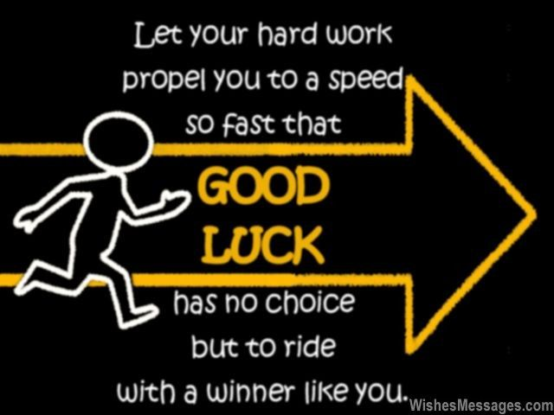

**H. Abbasi**