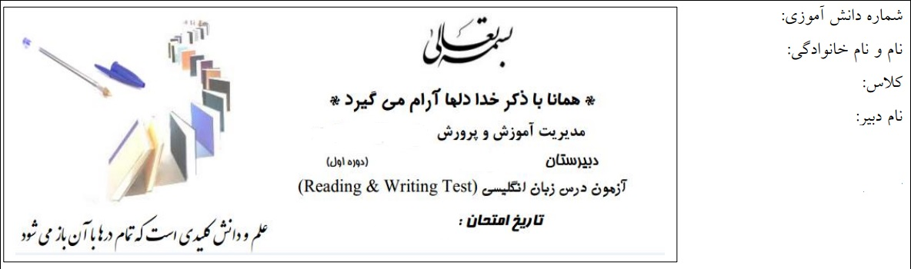
1.شماره تصویرمربوط به هر جمله را در زیر تصویر بنویسید . ( یک جمله اضافی است . )





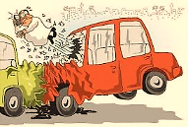

1.He’s funny. 2.He’s rude . 3. He’s careless.

4.He’s cruel . 5. He’s nervous.

2. کلمات نا هماهنگ را مشخص کنید :
1. helpful cruel friendly brave
2.patient quiet serious funny
3.book reserve check in travel
4.plane train bus bicycle

3. متضاد کلمات داده شده را بنویسید .
polite hard-working

4- جملات را کامل کنید :
[kind-neat-funny-careless]
1.My father is not ………………………. . He’s careful.
2. My sister is very ……………………….. . She’s not selfish .
3. My little brother is not serious . He is very …………………. .
4. I like my house . It’s very ………………. .

5- جملات را سوالی کنید :
1.A: ……………………………………………………………………… ?
B: No, he isn’t angry . He’s happy.
2.A: ……………………………………………………………………… ?
B: Yes, the house is clean.
3.A: ……………………………………………………………………… ?
B: No, they go by bus.
4.A: ……………………………………………………………………… ?
B: No, she speaks a lot and she’s noisy.
3. Look at the pictures and complete the sentences with the correct words.( 2 points )





4
3
2
1

1. My little sister is …………… she is not talkative.
2. This monkey is very ………………
3. Ali is a ………………… driver. He drives very fast.
4. She is a ………….. student. She is clever and kind. too.
4. Fill in the blanks . ( to be verbs ) ( 1/5 points )
I am pouya Ahmadi. I …… 13 years old. I go to shahid Beheshti
school. There ……. 35 student in my class. My friends ………..
kind and clever.Mr Alipour …... our English teacher. He ……
kind but he ……… nervous at all.


5. There are three mistakes in the text.find them and write correct form.( 1/5 )

That are Mr jack. He is a teacher. There is 22 students in the classroom. He is 45 years

old.The students is very clever .

6. Read the text carefully and find personality in it.( 1/5 )

Fariba is a clever student. Everybody likes her very much. She
is also helpful. She helps me with my English. She is neat and
brave ,too. She is 18 years old.

…………………… ……………………. ………………………
7. choose the correct forms.( 1/5 points )

a. Reza isn't / aren't lazy.

b. There is / are one teacher in the class.

c. There is a / an apple in the basket.

Good luck

