آموزش بافت پاپوش بچه گانه انگشتی

[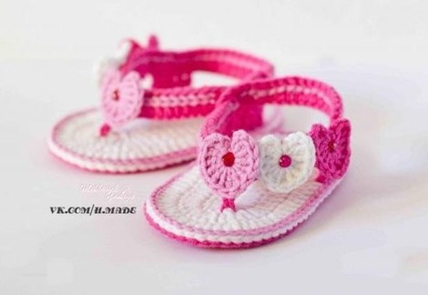](http://www.taradof.com/housekeeping/textural/fingered-footwear-children.html)

[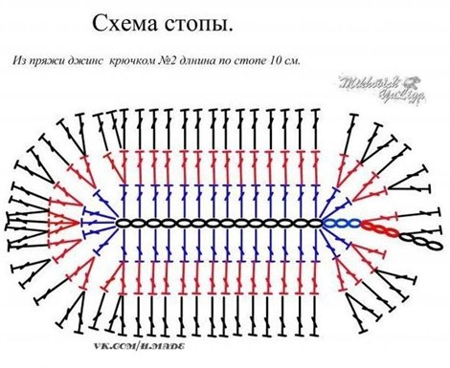](http://www.taradof.com/housekeeping/textural/fingered-footwear-children.html)

[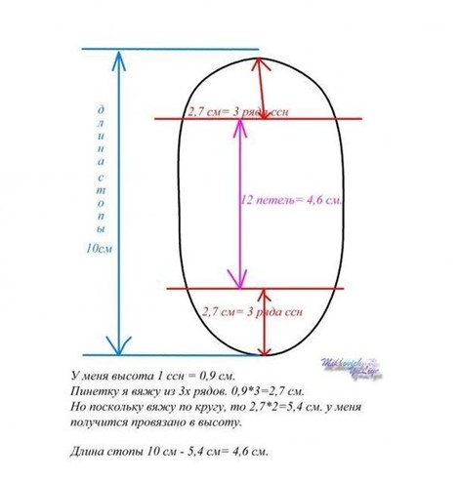](http://www.taradof.com/housekeeping/textural/fingered-footwear-children.html)

[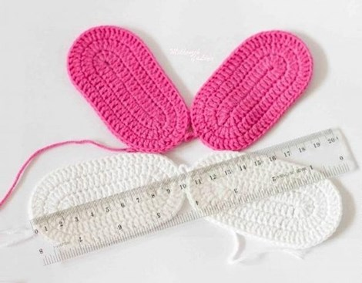](http://www.taradof.com/housekeeping/textural/fingered-footwear-children.html)

[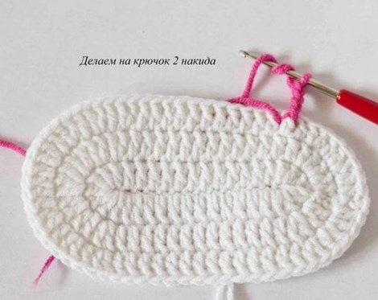](http://www.taradof.com/housekeeping/textural/fingered-footwear-children.html)

[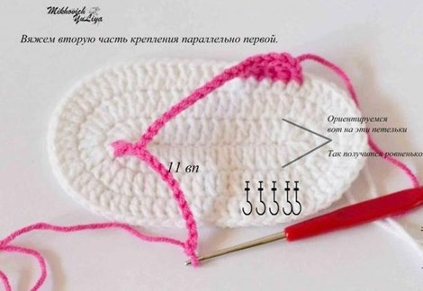](http://www.taradof.com/housekeeping/textural/fingered-footwear-children.html)

[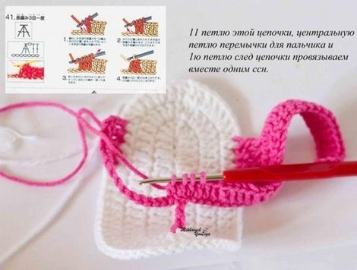](http://www.taradof.com/housekeeping/textural/fingered-footwear-children.html)

[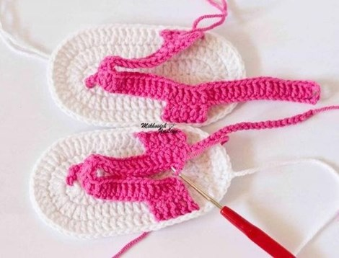](http://www.taradof.com/housekeeping/textural/fingered-footwear-children.html)